SEMESTER PROJECT

**BIOMETRIC ATTENDANCE SYSTEM**



**Govt.Graduate College Sheikhupura**

SUPERVISOR

**Prof. SHEHRISH KHAN**

SUBMITTED BY:

**MAWRA KHALIQ 049981**

SESSION: **2020-2024**

***Bachelor of Science in Information Technology***

**Abstract**

Manually taking attendance and maintaining it for a long time adds to the difficulty of this task as well as wastes a lot of time. For this reason, biometric attendance system is developed to solve the problem of manual attendance system. Biometric attendance system takes attendance of employees electronically with the help of a fingerprint recognition system, and all the records are saved for subsequent operations. Biometric attendance system helps the administrator to monitor and track the attendance of the employees easily. Biometric attendance system generate monthly attendance summary of employees in order to reduce human errors during calculations.

* **Introduction** ------------------------------------------------------------------------------------**1**
  + Purpose -----------------------------------------------------------------------------------1
  + Scope. ------------------------------------------------------------------------------------1
* **Overall Description** -------------------------------------------------------------------------------1
  + Product Perspective ---------------------------------------------------------------------1
  + Product Function --------------------------------------------------------------------------1
  + Operating Environment ------------------------------------------------------------------1
  + Design and Implementation Constraints ---------------------------------------------1
  + Assumptions and Dependencies -------------------------------------------------------2
* **External Interface Requirements** --------------------------------------------------------------**2**
  + User Interface -------------------------------------------------------------------------------2
  + Hardware Interface -------------------------------------------------------------------------2
  + Software Interface --------------------------------------------------------------------------2
  + Communication Interface -----------------------------------------------------------------2
* **System Features** --------------------------------------------------------------------------------------**3**
  + Business Requirements --------------------------------------------------------------------3
* **Other non- functional Requirements** ------------------------------------------------------------**3**
* **Other Requirements** -----------------------------------------------------------------------------------**3**
* **Vision of Solution** --------------------------------------------------------------------------------------**3**
  + Vision Statement -----------------------------------------------------------------------------3
  + Major Features --------------------------------------------------------------------------------3
* **Business Requirements** -------------------------------------------------------------------------**3**
  + Background ------------------------------------------------------------------------------------3
  + Business Opportunity -----------------------------------------------------------------------4
  + Business Objective and Success Criteria ------------------------------------------------4
  + Customer and Market Needs --------------------------------------------------------------4
  + Business Risks ----------------------------------------------------------------------------------4

Table of Content

**List of Figure**

Figure 1: Class Diagram……………………………………….….………….…………05

Figure 2: Component Diagram …………………………………….……….………06

Figure 3: Entity Relationship Diagram ………………………………….….……07

Figure 4: Context Diagram ……………………………………………..….…………08

Figure 5: Level 0 Diagram ……………………………………….………………….…08

Figure 6: Level 1 Diagram……………………………………………………….……..09

Figure 7: Use Case Diagram …………………………………………….…………….10

Figure 8: Employee Login ……………………………………….………………….….11

Figure 9: Admin Login ……………………………………………………………………12

Figure 10: Mark Attendance …………………..……………………………………..13

Figure 11: Check Report …………………………………………………..……………14

Figure 12: Generate Summary ………………………………………..……………..15

Figure 13: Sequence Diagram …………………………………………..……………16

Figure 14: Object Diagram ……………………………………………………………..17

Figure 15: Activity Diagram ……………………………..…………………………….18

Figure 16: Collaboration Diagram …………………………………………………..19

**1. Introduction**

**1.1 Purpose**

A biometric attendance system utilizes a fingerprint to allow employees to clock in and out of their office. An employee attendance monitoring system helps to see who is clocked in and at what time. You can be sure that you only pay your employees for the time they work. This attendance tracking system identifies and tracks employees’ attendance by using their physical characteristics such as fingerprints or iris scans. This type of system is useful for tracking employee attendance, preventing time theft, and improving security.

**1.2 Scope**

This proposed system will manage the process of attendance that will save in a specific database. Once the employee place his/her thumb on the fingerprint sensor or place her/his eye in front of the camera, it will directly save in the database and generate a message along with its arrival or departure timings. This saved info will help the finance department to pay their employees according to their working hours.

**2. Overall Description**

**2.1 Product Perspective**

Biometric Attendance System is an independent product and does not depend on any other system or product. This product will automate various tasks associated with handling employee’s detail and organize the stored information in a better way. This helps the organization to achieve its purpose.

**2.2 Production**

The major feature of biometric attendance management system is that it keeps a record of all essential details of individual employees. At the end of specified period, this system creates a list of Attendance percentages of each employee in every field would be displayed in this list. It is a secure cloud-based platform. It is simple and easy to navigate and it provides 24/7 accessibility. And payroll integration facility. And improves security.

**2.3 Operating Environment**

* This biometric attendance system shall function on a PC provided by the organization
* This system will record all the essential details of a particular employee.
* Higher RAM must be 1 GB or more and Hard Drive must be 10 GB or more.

**2.4 Design and Implementation Constraints**

The time allotted for this project is specifically 3 months.

The languages we will use for this project are MYSQL and Python.

**2.5 Assumptions and Dependiences**

* + - All non-academic staff of the institution have a unique employee ID for registration.
    - The authentication system is fed with the data to identify the admin.
    - Each staff belongs to a particular Department or Unit.
    - The captured attendance is stored on the database server and can be retrieved.
    - The administrator can track the attendance records of any non-academic staff.

**3. External Interface Requirements**

**3.1 User Interface**

This management system shall provide details of the employees. The details can be clicked with a mouse to view a particular employee record. All the modifications to the database will be done through the keyboard.

* 1. **Hardware Interface**

Server Side

* Operating System: Windows 10
* Processor: Pentium 3.0 GHz or higher
* RAM: 1 GB or more
* Hard Drive: 10 GB or more

Client Side

* Operating System: Windows 10 or above, MAC or UNIX
* Processor: Pentium 2 GHz or higher
* RAM: 1GB or more

**3.3 Software Interface**

This software will transmit the attendance to the database via the internet

The admin will allow to modify the record at any time

This system will communicate with the database to store, modify, or retrieve employee record

**3.4 Communication Interface**

The security of the user must be consistent through the use of a password

This system will communicate to the database through the internet.

**4. Business Requirements**

* Attendance Management
* Payroll integration facility
* Employee Management
* Leave & Exemption
* Time Management

**5. Other nonfunctional Requirements**

* Performance Requirements
* Security Requirements
* Safety Requirements
* Software Quality Attributes
* Business or Organization Rules

**6. Other Requirements**

* Software Requirement Specifications
* Random Access Memory
* Operating System
* Database
* Structure Query Language
* Hyper Text Transfer Protocol

**7. Vision of the Solution**

**7.1 Vision Statement**

This system takes attendance electronically with the help of fingerprint recognition or iris scans system and all the records are saved for subsequent operation. Staff biometric attendance system employs in an automatic system to calculate the attendance of staff in an organization and do further calculations of monthly attendance summary in order to reduce human errors during calculations. It tracks employee attendance by using their physical characteristics.

**7.2 Major Feature**

The major features of biometric attendance management system is that it keeps the record of all essential details of individual employee. At the end of specified period this system creates a list Attendance percentage of each employee of every field would be displayed in this list. It is a secure cloud based platform. It is simple and easy to navigate and it provide 24/7 accessibility. And payroll integration facility. And improves security.

**8. Business Requirements**

**8.1 Background**

The biometric era, organizations would mark the employees’ in-and-out timings in an attendance register, followed by their arrival and departure timings and signatures. As the data was centralized on a single file or register so there we a lot of chances for lost of data. By using this system the organization can make backup of all data. Therefore less chances for distortion of data.

**8.2 Business Opportunity**

* Increased security
* Improved employee efficiency.
* Reduces payroll cost
* Increased employee satisfaction
* Easy to deploy and integration

**8.3 Business objectives and Success criteria**

To design and implement circuit that will perform attendance taking process and supporting software module that will facilitate attendance tracking. Compare new system against traditional system. Speed and Throughput Rate – For biometrics system categorization, speed and throughput are crucial. Data-processing ability of the biometrics system determines the speed; it is declared as how quick the accept or reject decision is articulated.

**8.4 Customer and Market Needs**

This system will help the customer by tracking the employee’s attendance with their finger print and the record will remain safe in soft copy on a centralized device rather than in register where is a lot chances of data distortion. This system will keep in and out timing of employ in an organization. And handle leave management. Therefore, it saves a lot of time of customers and organization need.

**8.5 Business Risks**

* Costs – Significant investment needed in biometrics for security.
* Data breaches – Biometric databases can still be hacked.
* Tracking and data – Biometric devices like facial recognition systems can limit privacy for users.

**9.Class Diagram**

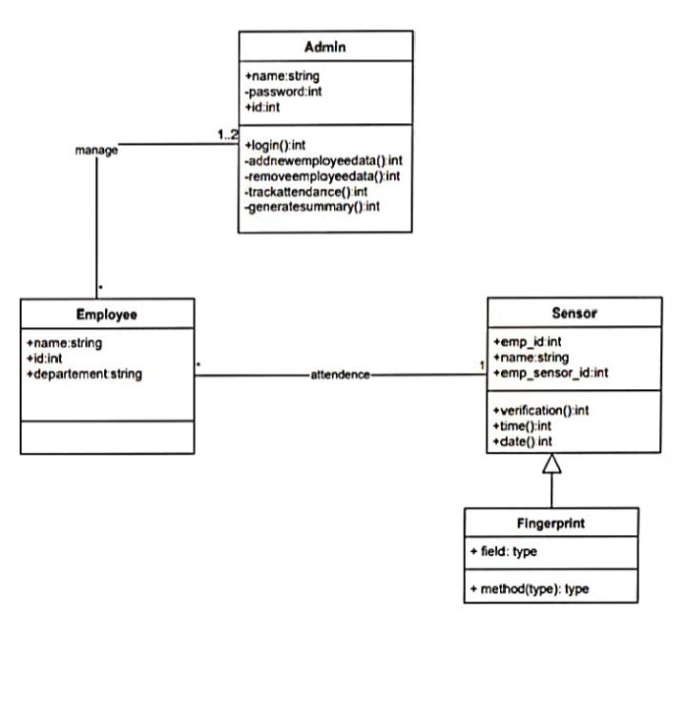

**Component Diagram**

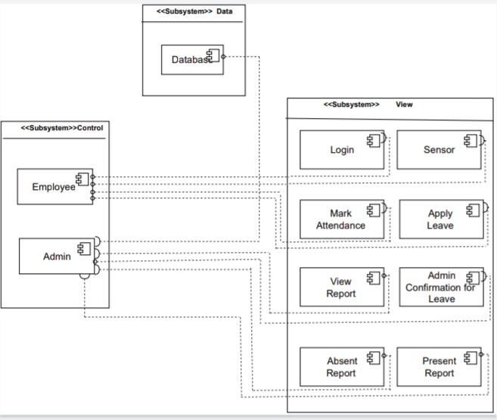

**11.Entity Relationship Diagram**

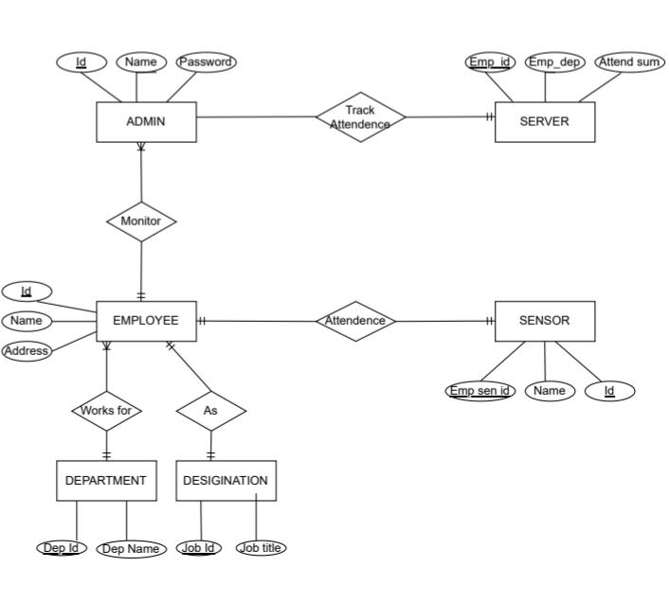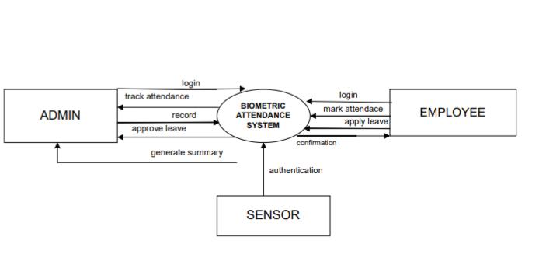

**12. Data Flow Diagrams**

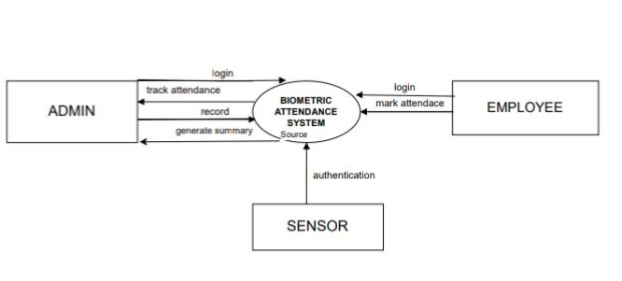

**12.1 Context Diagram**

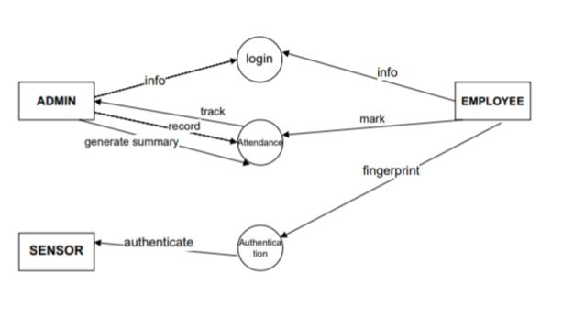

**12.2 Level 0 Diagram**

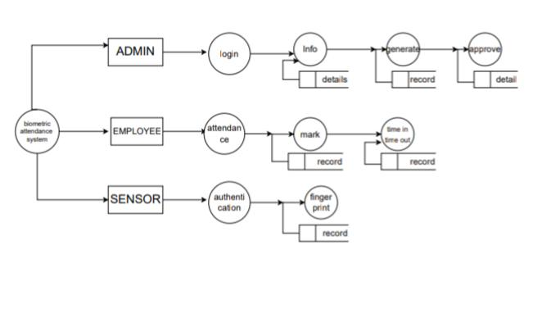

**12.3 Level 1 Diagram**

**Use- Case Diagram 10**

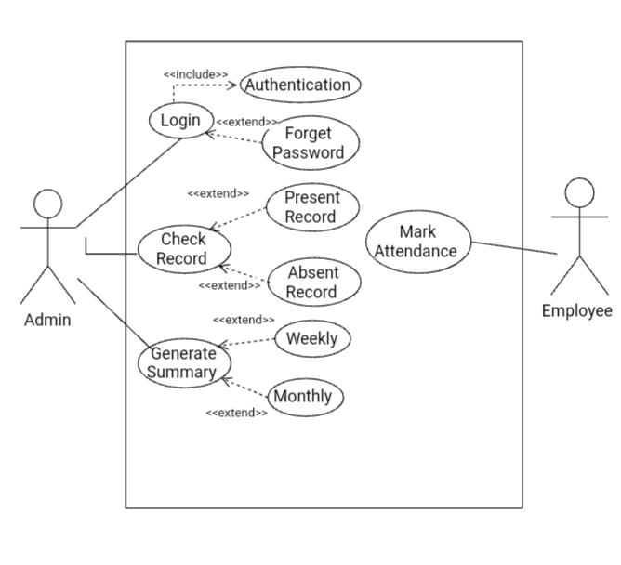

**Use Case Description 11**

1. **Admin Login**

Use Case No. UC-1

Use Case Name. Admin Login

Description: This use case describe mechanism of Admin trying to login.

Priority: High

Actor: Administration

Pre- Condition: The administrator must have an account for login. Such as user

name and password.

Post- Condition: Access is guaranteed.

Basic Flow: The flow will be

* + - * Admin open website to login so that he can manage the system
      * At home page there is a button of login
      * Admin click the button enter user name or password
      * Then there will appear two button login and cancel
      * Admin will choose the login one.

Exceptional flow: The flow can be

* Admin login may not work.
* Admin enter wrong username so the system will return action and ask to re-enter username.
* Admin enter wrong password so the system will return action and ask to re-enter password.
* There is an internet connectivity issue.

Post-Condition: The admin page will appear and admin can manage the system

Business Rules: None

1. **Employee login**

Use – Case No. UC – 2

Use-Case Name: Employee login

Description: The employee must have an account for login.

Priority: High

Actor: Employee

Pre- Condition: The employee must have an account for login. Such as user

Name and password.

Post- Condition: Access is guaranteed.

Basic Flow: The flow will be

* Employee open website to login so that he can mark attendance
* At home page there is a button of login
* Employee click the button enter user name or password
* Then there will appear two button login and cancel
* Employee will choose the login one.

Exceptional flow: The flow can be

* Employee login may not work.
* Employee enter wrong username so the system will return action ask to re-enter username.
* Employee enter wrong password so the system will return action ask to re-enter password.
* There is an internet connectivity issue.

Post-Condition: The page will open and employee can mark his attendance.

Business Rules: None

1. **Mark Attendance**

Use Case No: UC-3

Use Case Name: Mark Attendance

Description: This use case is used to mark attendance.

Priority : High

Actor: Employee

Pre-Condition: Pre conditions are as follows

* Employee has logged in to the system.
* Employee has the rights to mark attendance.

Post-condition: Employee marks attendance successfully.

Basic Flow: The flow will be

* Employee has logged in to the system.
* Employee mark his attendance through his finger print eye retina.

Exceptional Flow: Employee is unable to mark attendance because of

sensor issue.

Business Rule: Authorized employee has rights to mark attendance.

**Check Report**

Use Case No: UC-4

Use Case Name: Check Report

Description: This use case is used to check report.

Priority : Medium

Actor: Admin

Pre-Condition: pre conditions are as follows

* Admin has logged in to the system.
* Admin has the rights to check report.

Post-condition:. Admin check the reports successfully.

Basic Flow: Admin check the data weekly or monthly.

* Admin check the time-in and time-out of the Employees.
* Admin check the absents and leave of the employees.

Exceptional Flow: The flow can be

* Admin is unable to check report because of

Connectivity issue

* The generate summary function is not work properly.

Business Rule: Authorized admin has rights to check report.

1. **Generate Summary**

Use Case No: UC-5

Use Case Name: Generate Summary

Description: This use case is used to generate summary.

Priority : Medium

Actor: Admin

Pre-Condition: pre conditions are as follows

* Admin has logged in to the system.
* Admin has the rights to generate summary.

Post-condition: Admin generate the summary of employees

attendance successfully..

Basic Flow: Admin check the data weekly or monthly.

* Admin check the time-in and time-out of the

Employees.

* Admin check the absents and leave of the employees.
* Admin generate the summary of employees from The above data.

Exceptional Flow: The flow can be

* Admin is unable to generate summary because of

connectivity issue.

* The generate summary function is not work properly.

Business Rule: Authorized admin has rights to generate summary.

**S**

**Sequence Diagram**

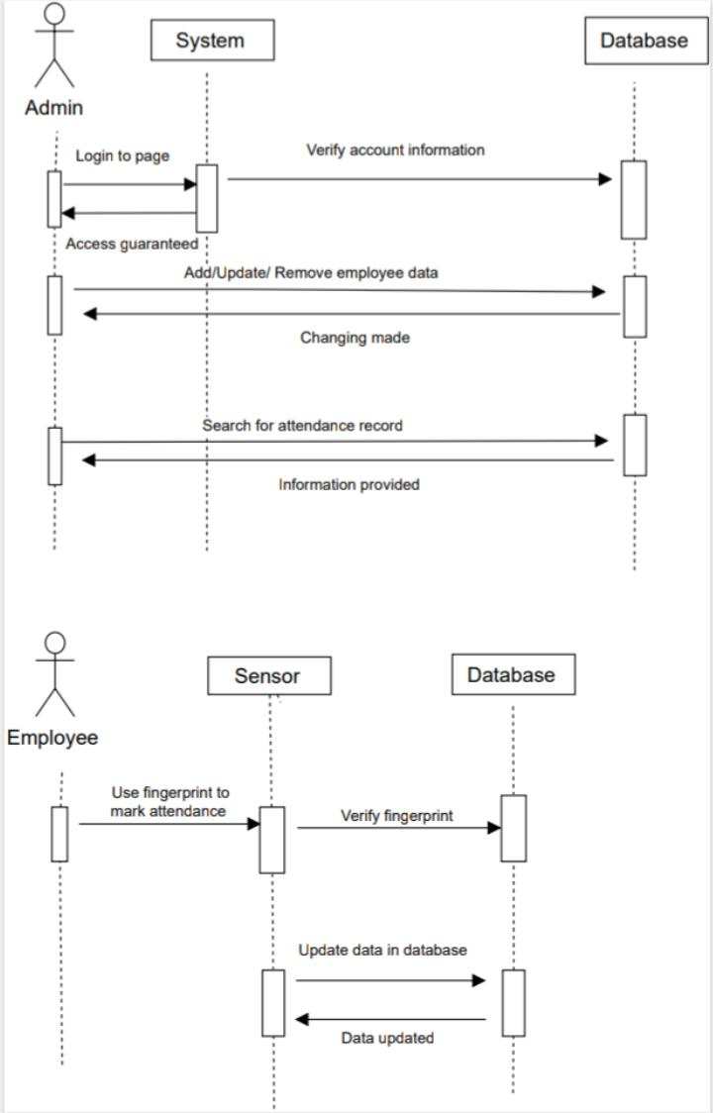

**Object Diagram 17**

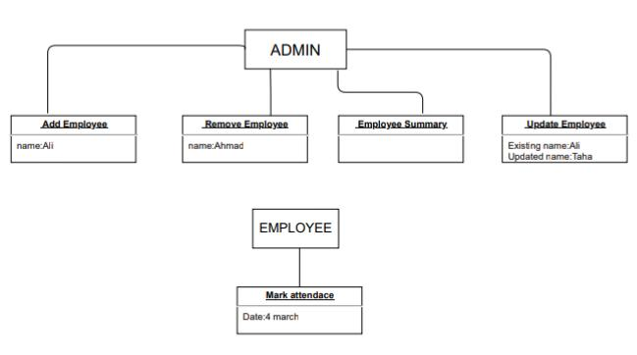

**Activity Diagram 18**

1. 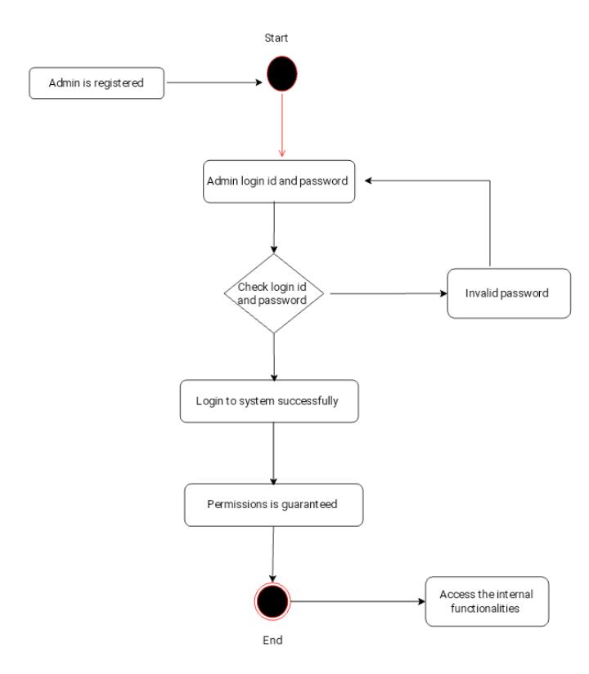**Employee 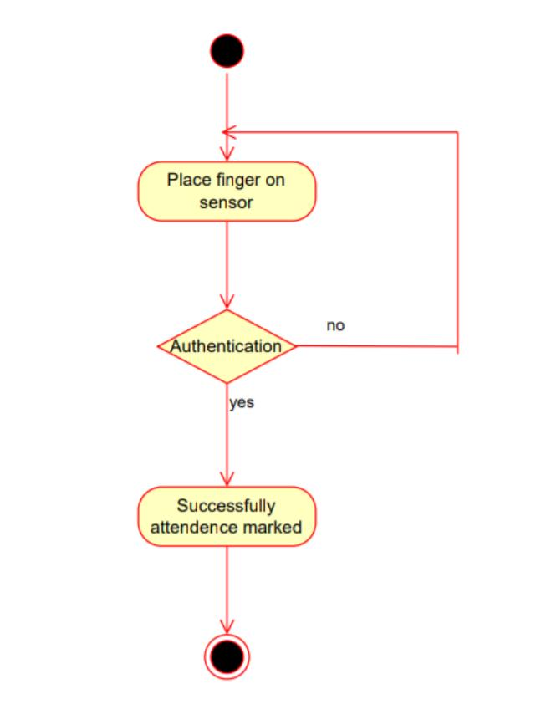 2. Admin**

**Collaboration Diagram**

